**Meeting Minutes**

Date: April 3, 2017

Place: A Table near Stop 1

Team: Dr. Stranger

Attendants: Jiacheng CHEN, Jiahuan HE, Jiayu WANG, Yiming JIANG

Brief: Our team went through what had been achieved by last week, agreed on a few admin issues, made overview of requirements again, and specified the tasks assigned to individuals.

1. **Review Previous Tasks**

First of all, we reviewed the tasks done in last week. We implemented a Resource class that can be shared by all our functions, and then we completed two of the functions on the server side.

1. **Admin**

We had decided to assign the task of meeting minutes to Jiayu Wang, because she was experienced in summarizing and displaying information. We had emphasized on creating new git branch while working concurrently and pull the most updated resources in time.

1. **Requirements Overview**

We went through the whole process from typing in commands to delivering final messages together, clarified anything unclear, and discussed the expected input and output of each function. We attached one of the discussing drafts below.

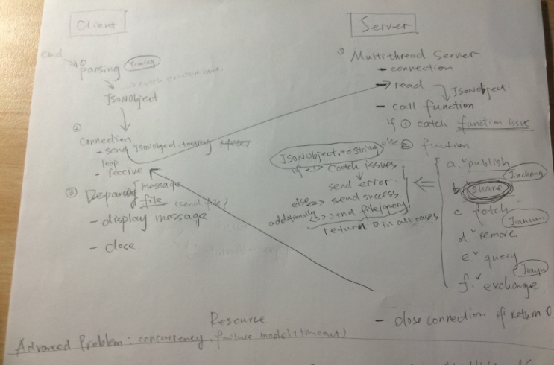

***Pic 3.1* Discussion Draft**

1. **Implementation Specification**

In addition, we discussed several implementation details for a few functions. For instance, the transmission problem of share and fetch function. We decided to let each function to deal with their own errors and transmission separately instead of centrally.

1. **Task Allocation**

We had agreed on the importance of submitting jobs on time, and made the following allocation.

Jiacheng CHEN : PUBLISH and SHARE function

Jiahuan HE : FETCH and REMOVE function

Jiayu WANG : Client and Multi-thread Server

Yiming JIANG : Marshalling and Unmarshalling